**Practical 0**

1. **Installation of Red HAT/Fedora Linux operating system.**
2. **Partitioning drives**
3. **Configuring boot loader (GRUB/LILO)**
4. **Network configuration**
5. **Setting time zones**
6. **Creating password and user accounts**
7. **Shutting down**

**Steps of RedHat Linux Installation**

**(1) Red Hat Linux Boot screen:**

After configuring the system for booting from a CD, the Red Hat Linux Boot screen appears. At this point, press Enter for the graphical Setup.

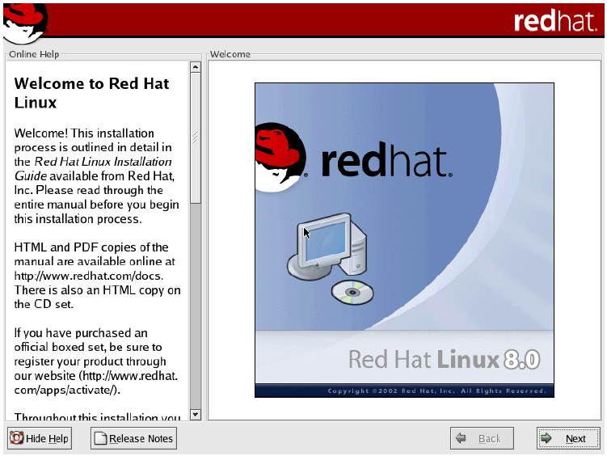

**(2) Welcome to Red Hat:** The "Welcome to Red Hat" screen appears with the option of **Hiding the help pane** (left side) or viewing the **Release Notes**. Select **Next** when ready



**3) Language Selection:** The **Language Selection** screen displays all of the languages available to install Red Hat with. I chose **English** here, then **Next**.



**(4) Keyboard Configuration:** Keyboard Configuration is next. Highlight the best match for your particular system. Usually, the default works best. Select **Next** when complete



**(5) Mouse Configuration:** Mouse Configuration is next. Again, highlight the best match for your particular system. Select **Next** when finished



**(6) Installation type:** Selection of a standard installation type is now available. The options include **Personal Desktop**, **Workstation**, **Server**, or **Custom.** For this particular guide, I selected **Personal Desktop** and then **Next. Image**



**(7) Partitioning your system:** You are now faced with the option of automatically partitioning your system with the default values or selecting a more expert approach of choosing exactly what values each partition will be. I chose **Automatic**, then selected **Next**



**(8) Warning dialog box:** If this is a new hard drive or a hard drive that no partitions currently exist, a warning dialog box will appear. Select **Yes** to continue.



**(9) Automatic Partitioning:** Here are the options of deleting all Linux partitions, deleting all partitions, or keep the disk structure as it already is. If this is a new drive, any options work just fine, but, if you already have partitions defined, as in a Multi-Boot environment, be careful as to which selection and drive volume you choose. Also, check the **Review and modify** box at the bottom to retain control over what happens to the hard drive and view the recommended configuration.



**(10) New hard drive structure:** If you checked the **Review and modify** box, the new hard drive structure is displayed. This fits my purposes, so I chose **Next** to continue.



**(11) Boot loader options:**Boot Loader options are displayed. If this is the only OS to be installed, I recommend to install a boot loader, such as Grub (the default). If this is part of a Multi-Boot System, I recommend to *not* install a boot loader and use a boot floppy, created later on in the install process, instead. **Important: If you chose to *NOT* install a boot loader and *NOT* make a boot floppy, your Red Hat installation will *NOT* work.**



**12) Install a boot loader:** Please view my Multi-Boot Guide for more information about Boot Floppies. **Image**



**13) Network setup:** Network setup options are next. Enter in the required information for your particular setup, here. I chose the default, **DHCP setup**, then selected **Next**



**(14) Firewall setup:** Firewall setup is very important! If this system will be connected directly to the internet, choose **High** to start out with. If this system is already behind a hardware firewall or router, choose **Medium** as a good starting point.



**(15) Language Selection:** Additional Language options are also available. Since I understand no other language besides **English**, the default was fine.



**(16) Time Zone Selection:** Configure your Time Zone with this display. Being on the West Coast, Pacific Time was selected here. Choose what is right for your location and then select **Next** to continue



**(17) Create a root or administrator password:** Another important part of the installation process is to create a root or administrator password and a "normal" user account for everyday tasks. *DO NOT* leave your root password as blank or easily guessable



**(18) Add users:** After acceptance of your root password, select the **Add** button to create an additional account for everyday tasks. Do not worry. If at anytime you need to use the root account to change system settings, you can. You will be prompted for the password even if you are logged in as a regular user. After creating a new account and selecting a "good" password, select the **OK** button.



**19) Add as many users as you wish:** Your display could look something like this. Add as many users as you wish, then select **Next** to continue.



**(20) Default package configuration:** Here, you have the option of accepting the default package configuration, or selecting exactly what applications and services you desire. If you wish, you can skip this step and select **Next** as the default option and your system will be configured accordingly. However, if you desire to add or subtract particular applications, choose the **Customize packages to be installed** button and select **Next**.



**(21) Selecting exactly what packages:** Here you will have the option of selecting exactly what packages and applications you wish to install. Detailed descriptions about each are also available, after selecting the check box on the left of the category, by selecting the **details** button. Upon completing your options, select **Next** to continue.



**(22) Installation will now start:** Installation will now start after selecting the **Next** button.



**(23) Formatting of the hard drive:** Formatting of the hard drive or partitions will begin. Depending on the size of the hard drive, this may take much time.\



**(24) Transfer of the install image:** Transfer of the install image to the hard drive now takes place. Again, if you selected many packages, this could take some time.



**(25) Installation of all selected packages:** Installation of all selected packages and applications are now underway. Depending on what was selected and system configuration, this could take 15 minutes to over an hour.



**(26) Insert the next CD soon:** Do not go far, though, as you may be required to insert the next CD soon. **Image**



**(27) Boot floppy creation:** If this is the only OS to be installed, I recommend to install a boot loader previously, such as Grub (the default). This does NOT mean that you should forget about creating a boot floppy, also. If this is part of a Multi-Boot System, I recommend a boot floppy, created here, and not to use a boot loader. **Important: If you chose to *NOT* install a boot loader and *NOT* make a boot floppy, your Red Hat installation will *NOT* work.** Please view my Multi-Boot Guide for more information about boot floppies.



**(28) Graphics card setup:** Select your graphics card setup and memory configuration here. Chose **Next** after highlighting your selection.



**(29) Monitor Setup:** Enter the proper values or highlight the model of your display here. After selecting the configuration for your system, chose **Next**



**(30) Desktop resolution:** Choose your desktop resolution and bit-depth. Capabilities beyond your card should not be displayed.



**(31) Install complete:** Installation is completed and the system will reboot after selecting **Next**



**(32) Grub boot loader:** Upon reboot, the Grub (if selected previously in the install process) is displayed with the option of booting your Linux installation. If you opted for a boot floppy, ensure that your system is configured to boot from "A:" first, then your hard drive, otherwise, your system may skip to your previous OS by default.



**(33) Boot Red Hat:** Keep in mind, while the OS is loading, Linux is famous for allowing the USER to choose exactly what, how and why everything happens. This is not Windows. You will see all kinds of information about the internal workings of your system. Do not be alarmed. You will come to enjoy that information in due time. :) **Image**



**(34) Logon:** If you opted for a graphical install screen, the **user name** prompt is displayed. Log in as one of the users you created previously (*not* root) and enter in your password (*not* blank).



**(35) Gnome Desktop:** The Red Hat 8.0 default desktop is now displayed. If you selected KDE and not Gnome, your view will be slightly different. Remember, anything that you wish to do, you can, including messing with system files. When in doubt, think twice. :)



**(36) BlackViper.com in Mozilla:** I had to fire up Mozilla 1.0.1 to ensure my internet connectivity functioned, and it worked great! Thank you for viewing my install guide and I hope it has helped you gain an insight to what may be required before taking the Red Hat plunge.



**Shutdown:** The shutdown command will perform the following activities

**(1)** Sends signals to all running processes so that they terminate normally.

**(2)** Logs user off and kills remaining processes.

**(3)** Un mounts all secondary files.

**(4)** Writes information about file system status to disk preserve the integrity of the file system.

**(5)** Notifies users to reboot or switch off, or moves the system to single user mode.

The –g option to shutdown overrides the default waiting time of one minute. The command can be used in these way- Shutdown –g5 power down machine after 5 minutes. Shutdown –y g0 immediate shutdown. Shutdown –y –g0 –i6 shutdown and reboot.

**Software selection and installation**

**Steps for installation of package**

**(1)Default package configuration:** Here, you have the option of accepting the default package configuration, or selecting exactly what applications and services you desire. If you wish, you can skip this step and select **Next** as the default option and your system will be configured accordingly. However, if you desire to add or subtract particular applications, choose the **Customize packages to be installed** button and select **Next**.



**(2) Selecting exactly what packages:** Here you will have the option of selecting exactly what packages and applications you wish to install. Detailed descriptions about each are also available, after selecting the check box on the left of the category, by selecting the **details** button. Upon completing your options, select **Next** to continue.



**(3) Installation will now start:** Installation will now start after selecting the **Next** button.



**(4) Formatting of the hard drive:** Formatting of the hard drive or partitions will begin. Depending on the size of the hard drive, this may take much time.



**(5) Transfer of the install image:** Transfer of the install image to the hard drive now takes place. Again, if you selected many packages, this could take some time.



**(6) Installation of all selected packages:** Installation of all selected packages and applications are now underway. Depending on what was selected and system configuration, this could take 15 minutes to over an hour.



**(7) Insert the next CD soon:** Do not go far, though, as you may be required to insert the next CD soon. **Image**



**Practical 1**

**AIM :** Study of Basic and Advanced Linux Commands

i. Create three empty files with the name a1, b2, c3.

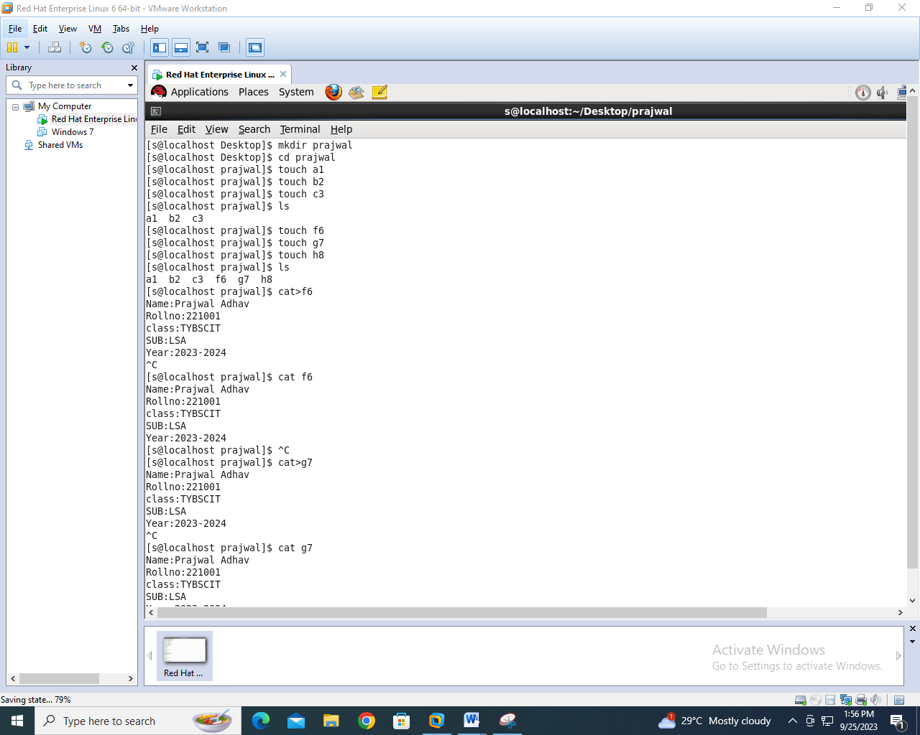

ii. Create three files with the name f6, g7, h8 using cat command with some meaningful contents with atleast five lines each.



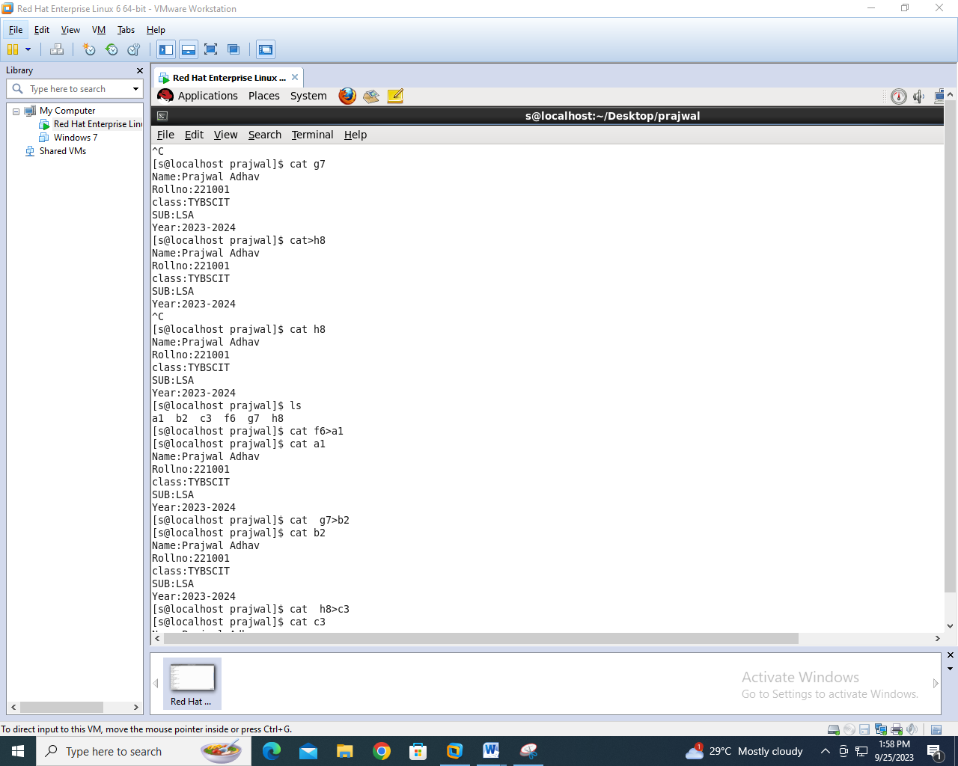

iii. Copy contents of f6 to a1, g7 to b2, h8 to c3.



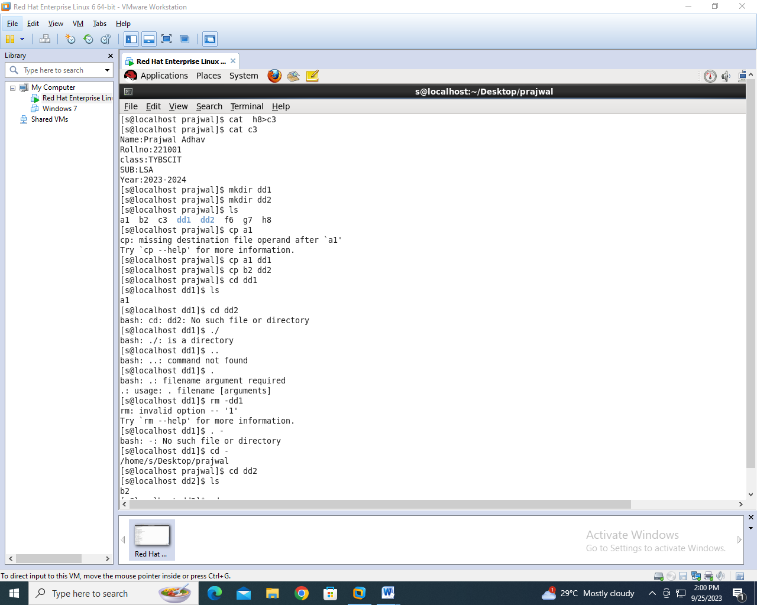

iv. Create two directories with the name dd1, dd2.



v. Copy the files a1 to the directories dd1.Copy the files b2 to the director dd2.



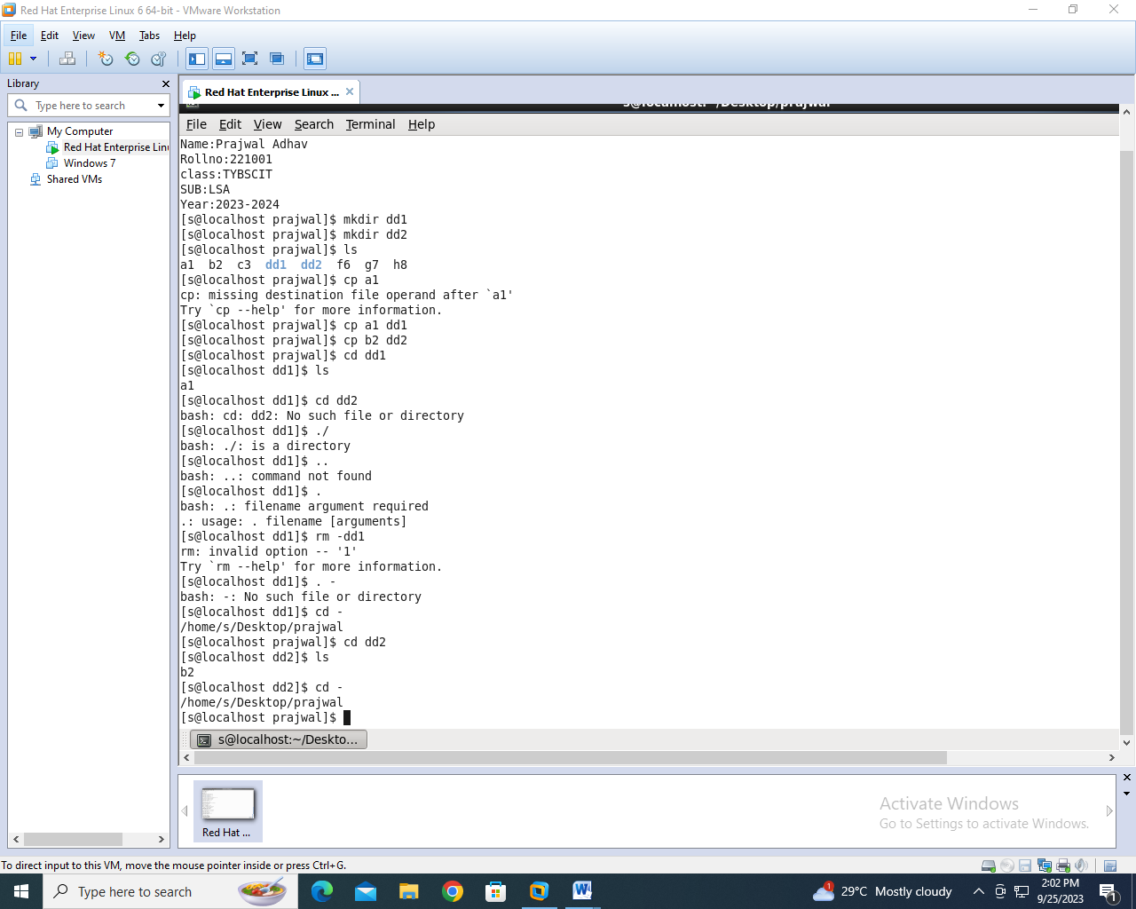

vi. Remove the directory dd2 along with its contents.

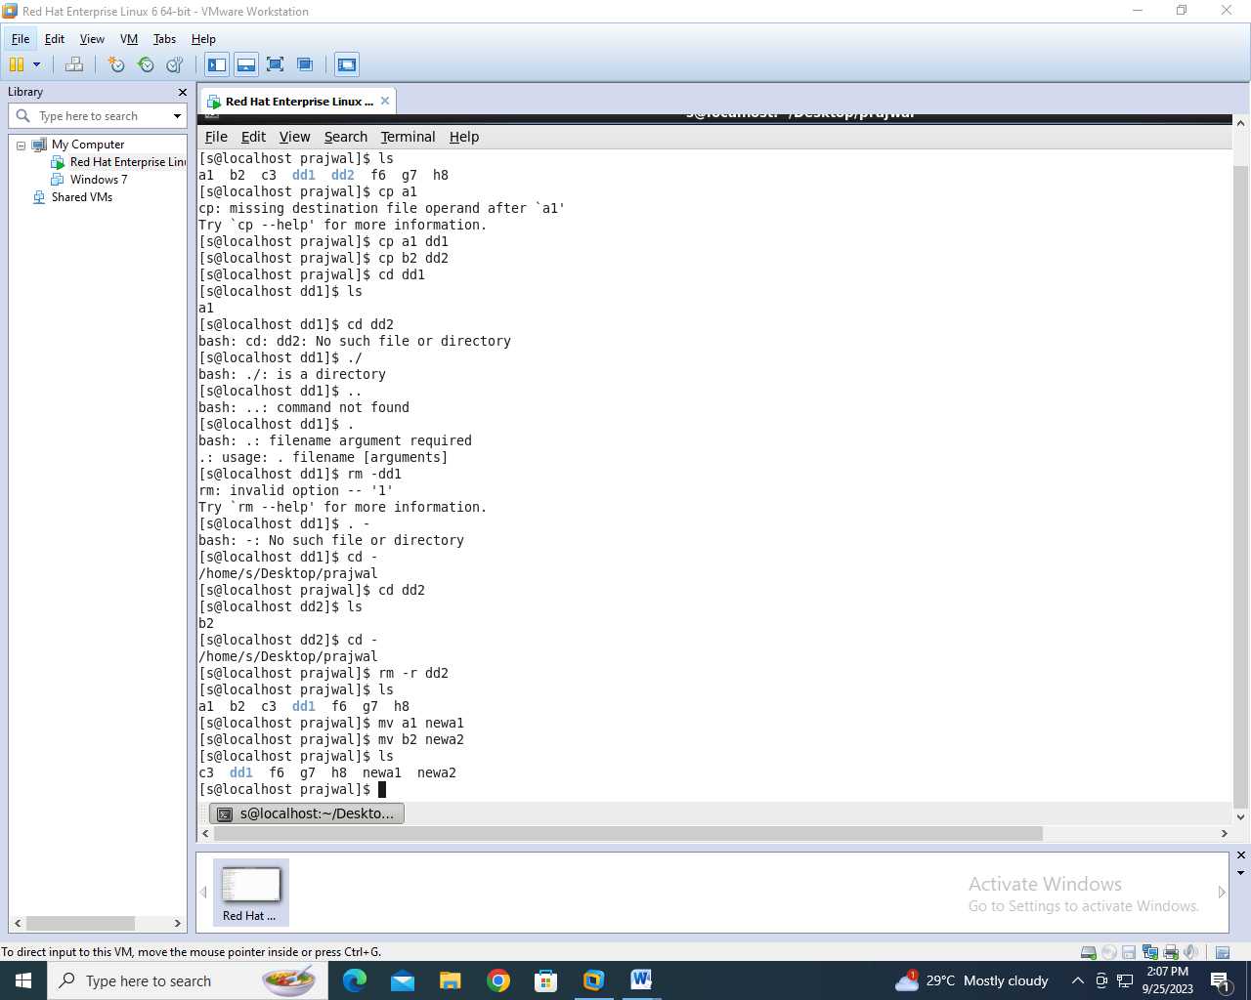

vii. Rename the files a1 and b2, by newa1 and newb2.



viii. Display the login name of all users currently logged in the system.

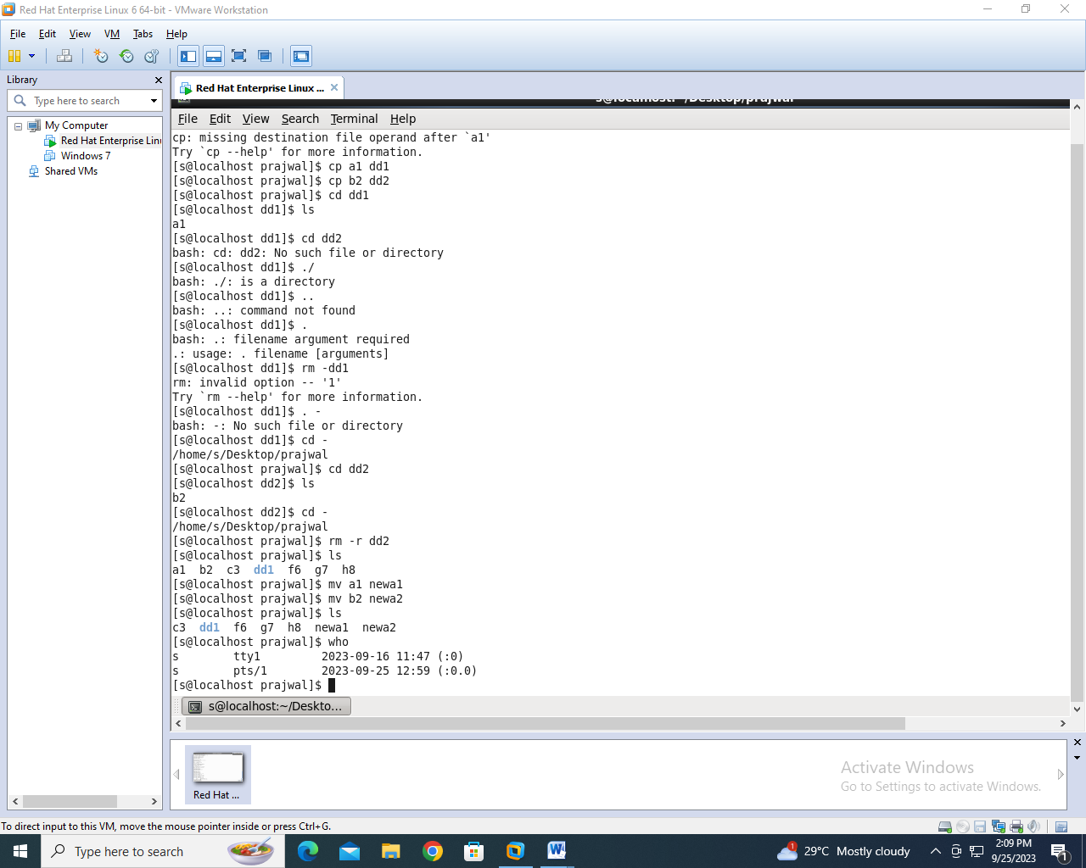

**Practical 2**

**AIM :** Storage Device and Links, Backup and Repository

**Mounting USB to system**

Step 1: Open the terminal windowand type su command to take root user permission and type **df**command to find the device name and partition with the name of /dev/sdb1. (insert your pendrive in usb and then see the line)

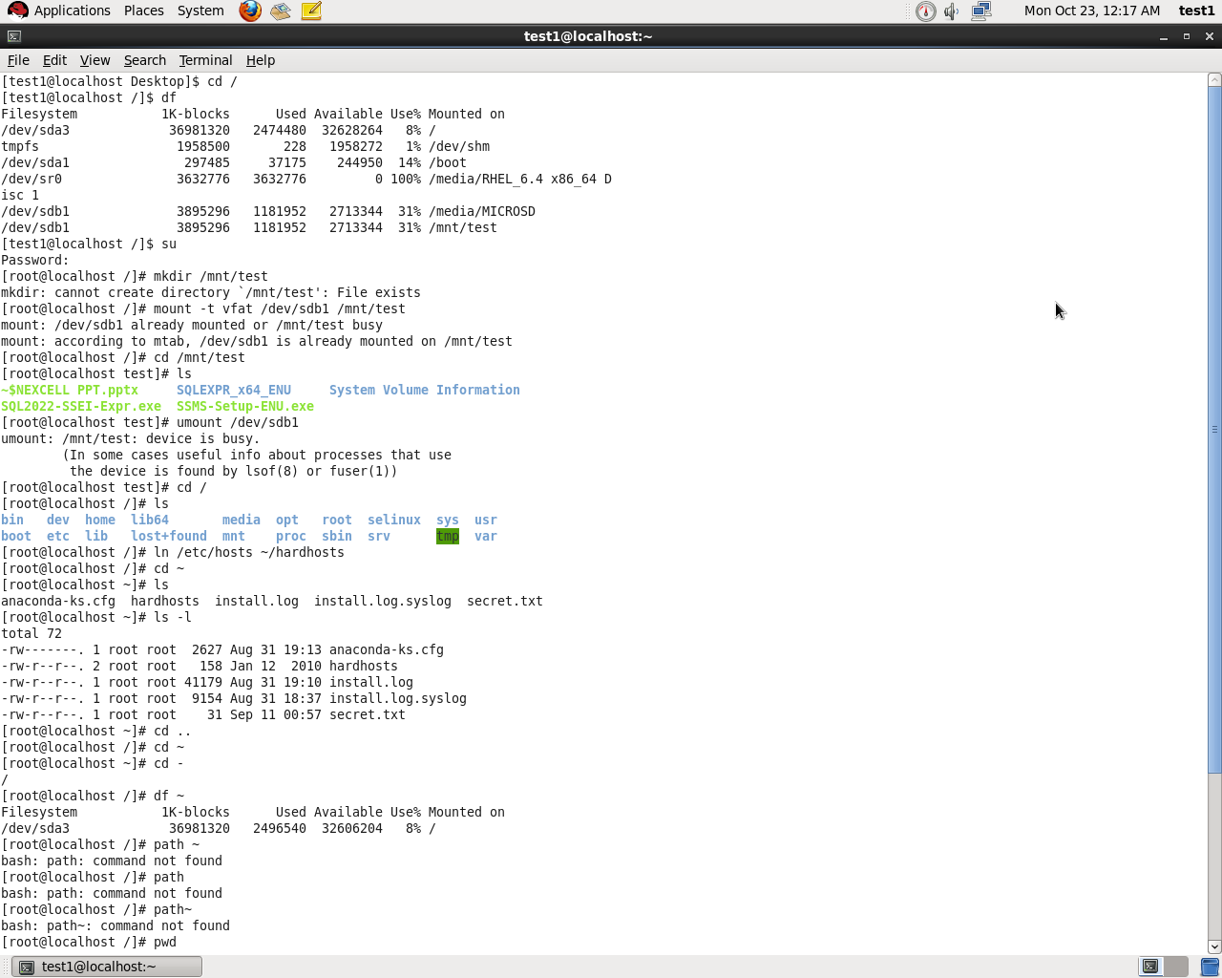

Step 2 : Create a mount point

Mkdir/mnt/test

Step 3 : use mount -t vfat/dev/sdb1 /mnt/test to mount the USB flash drive on the /mnt/test directory.

Step 4 : use cd /mnt/test to go into /mnt/test directory and type Is command to verify that you can see the content USB flash drive.





**LINKS**

To create a link, you need the **In command.**

Use the command **In/etc/hosts~/hardhosts.** The create a hard link w ith the name hardhosts in your home directory.

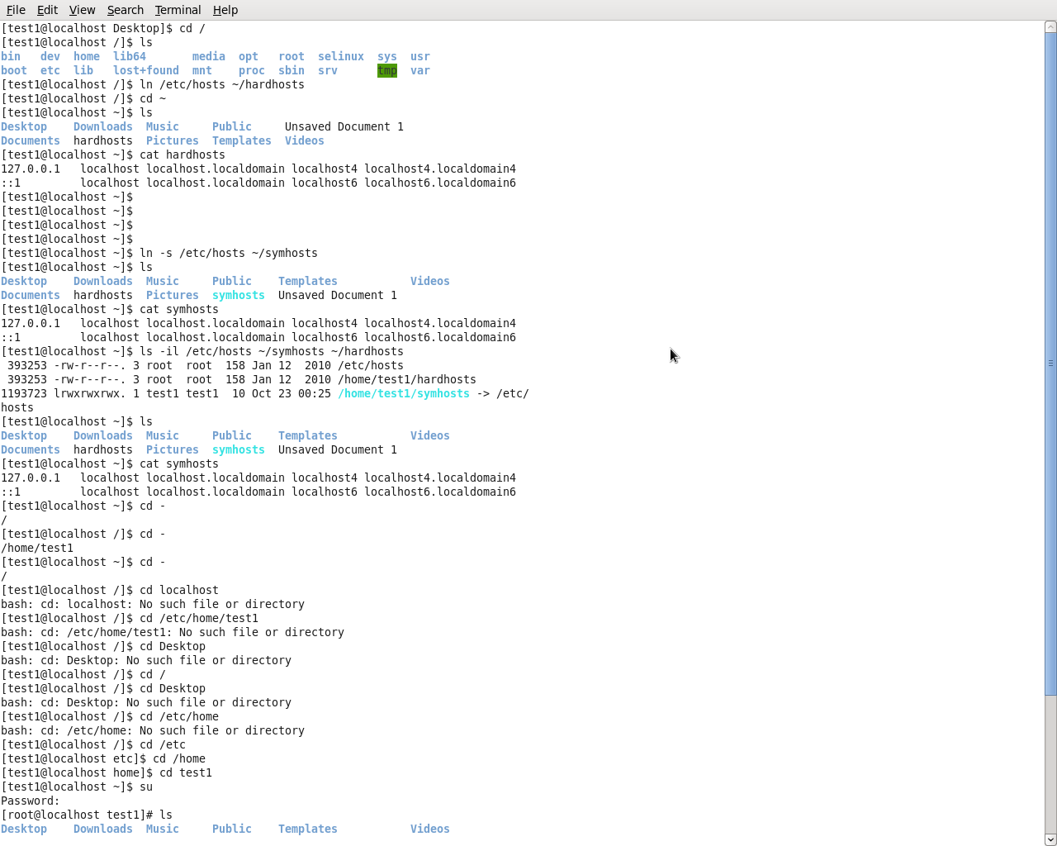

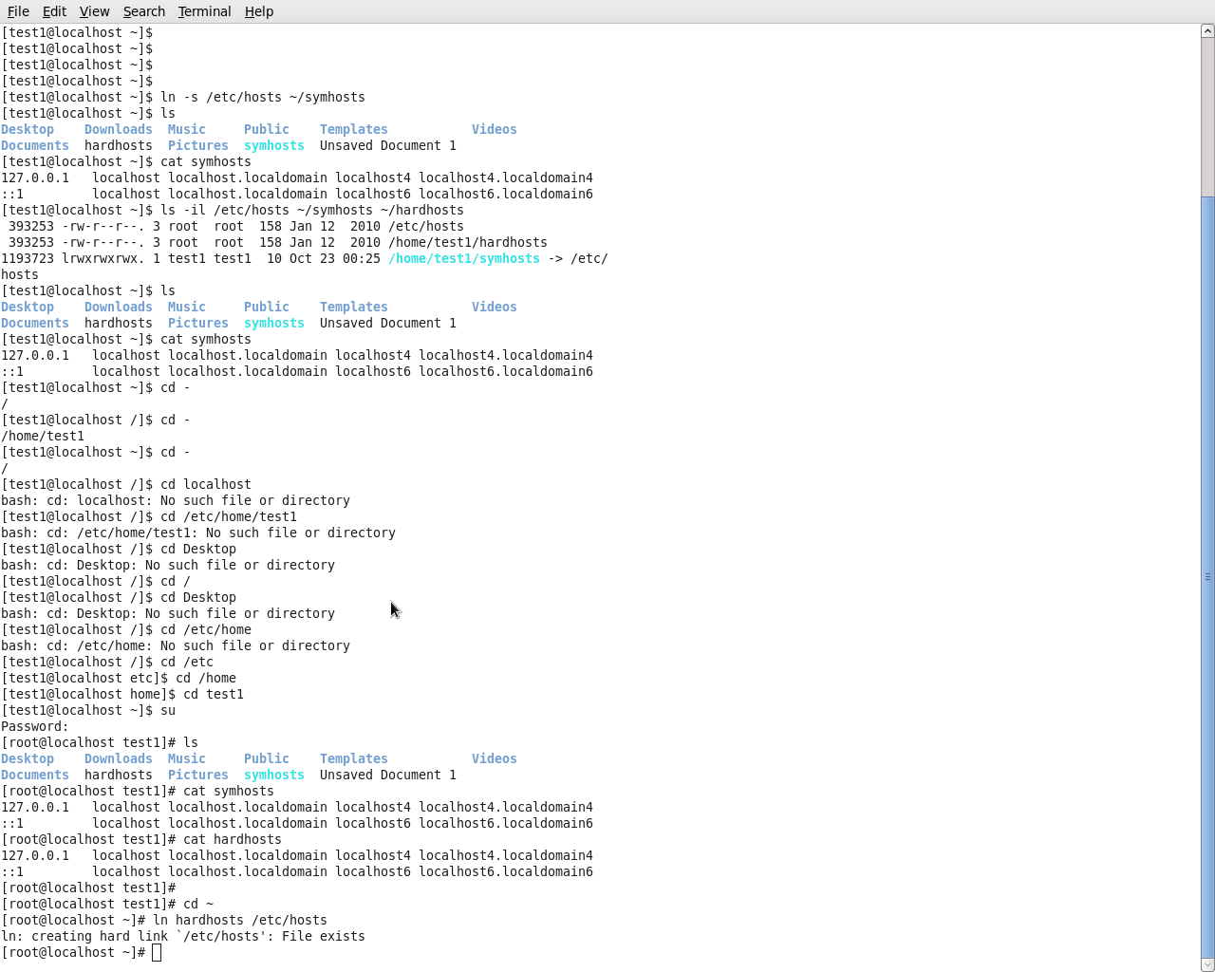

**Practical 4**

**AIM :** Working with Users, Groups, and Permission

**useradd** This command is used for adding users to the local authentication system. **useradd** will read its configuration file in /etc/default/useradd.

**id command** is used to verify the user is created or not

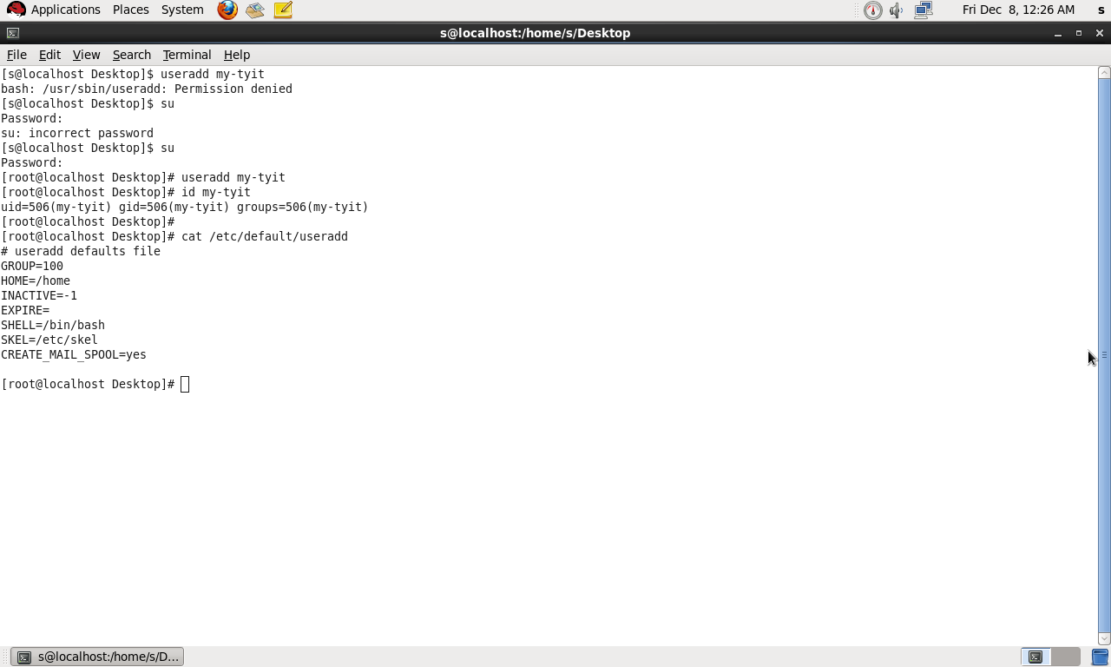

**Managing Passwords**

To enable these users, assign passwords using the passwd command.The root user can change passwords as well. To set the password for a user, root can une paused followed by the name of the user whose password needs to be changed.

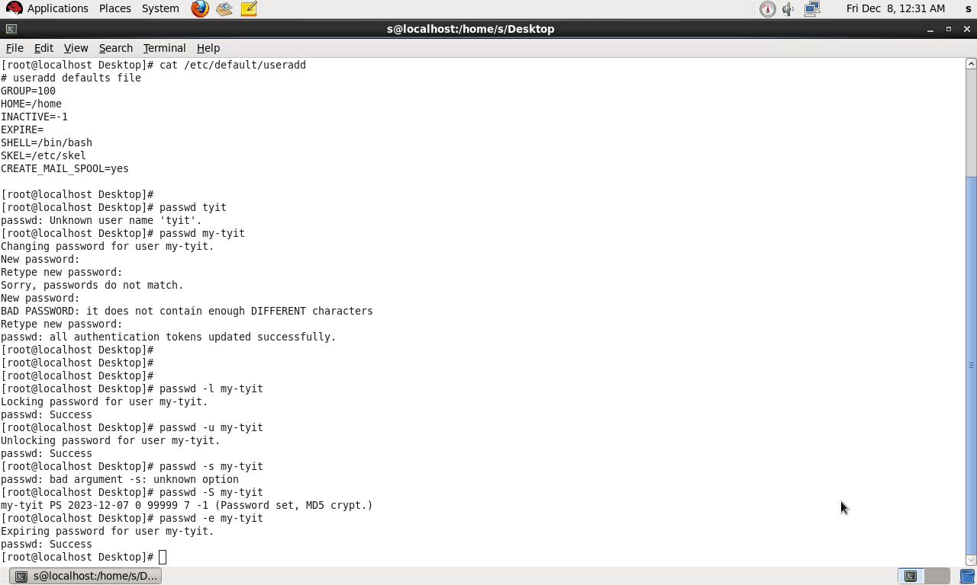

**Performing Account Maintenance with passwd-**

To perform these tasks, the passwd command has some options available

**-l** Enables an administrator to lock an account. For example, passwd -I lucy will lock the account for user.

**-u** Unlocks an account that has been locked before.

**-s** Reports the status of the password for a given account.

**-e** Forces the user to change their password on the next login



Open the file /etc/login.defs with an editor. Locate the variable CREATE_HOME and change its value to no. close the file and save the changes to disk.

**# vi /etc/login.defs**

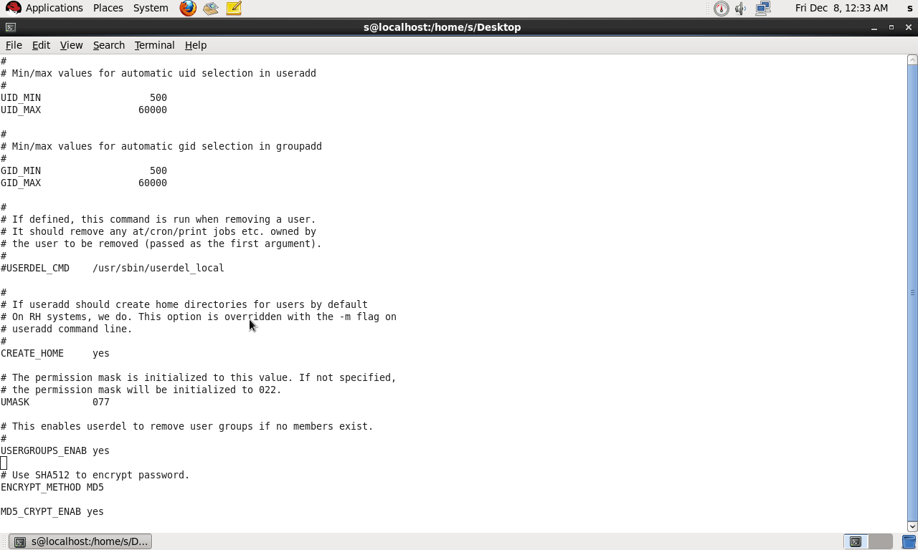

**Modifying and Deleting User Accounts**

The usermod command is used for modifying an existing user account. For example, use usermod -u 555 my-tyit to set the new primary user-id of user my-tyit to a user with the unique ID 555.

userdel. Use this command to delete accounts from your server. userdel is a very simple command: userdel my-tyit deletes user my-tyit from your system

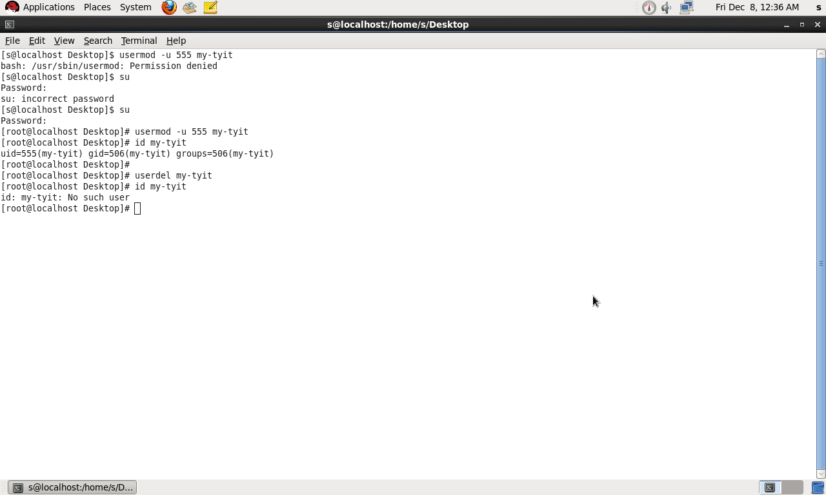

**Commands for Group Management**

There are three commands to manage the groups in your environment: groupadd, groupdel, and groupmod. All groups on your system are defined in the configuration file /etc/group.

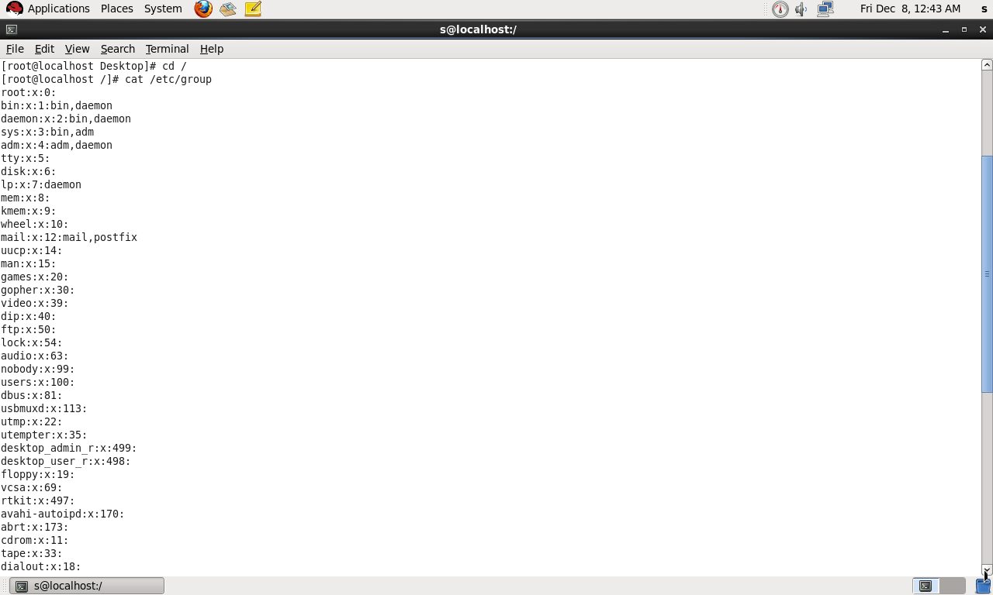

**Understanding Read, Write, and Execute Permissions**

- Use the chmod command to apply permissions.

- When using chmod, you can set permissions for user, group, and others.

- You can use this command in two modes: relative and absolute.

- When setting permissions, calculate the value you need.

- For example, if you want to set read, write, execute(4+2+1) for the user, read and execute(4+1) for the group, and read and execute (4+1) for others on the file /somefile,

- you would use the chmod command chmod 755 /somefile.

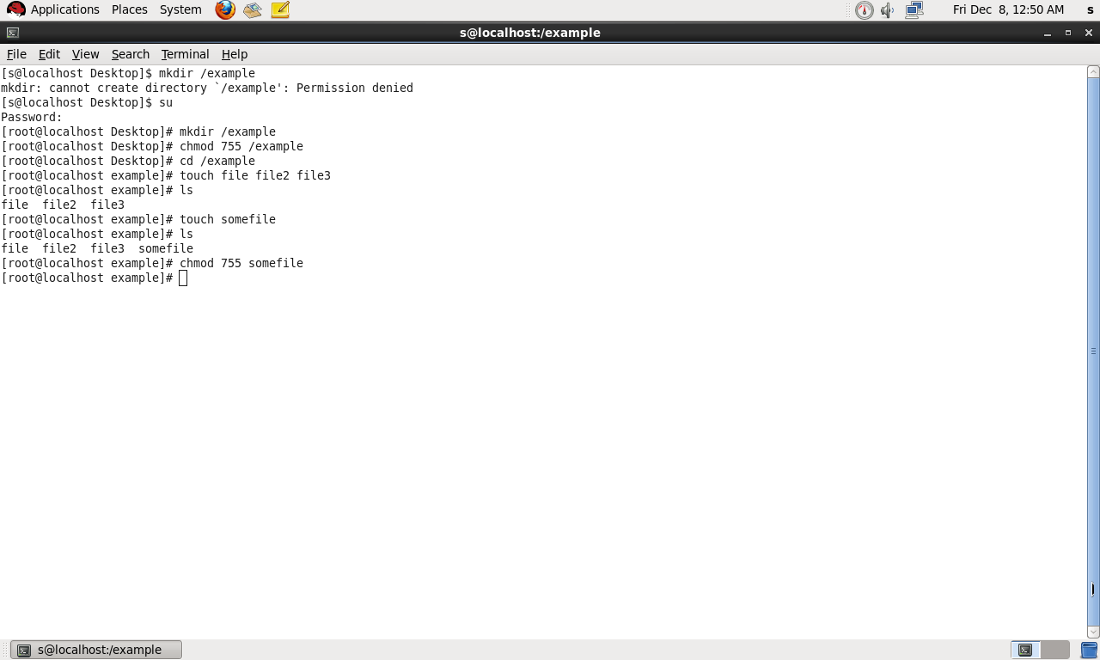

When using chmod in relative mode, you work with three indicators to specify what you want to do.

To do this, you can choose between user (u), group (g), and others (o).

Next you use an operator to add or remove permissions from the current mode or set them in an absolute way.

At the end, you use r, w, and x to specify the permissions you want to set.

For example, **chmodo+xsomefile** would add the execute permission for all others.

For example , **chmod +x somefile** would add the execute permission for all users.

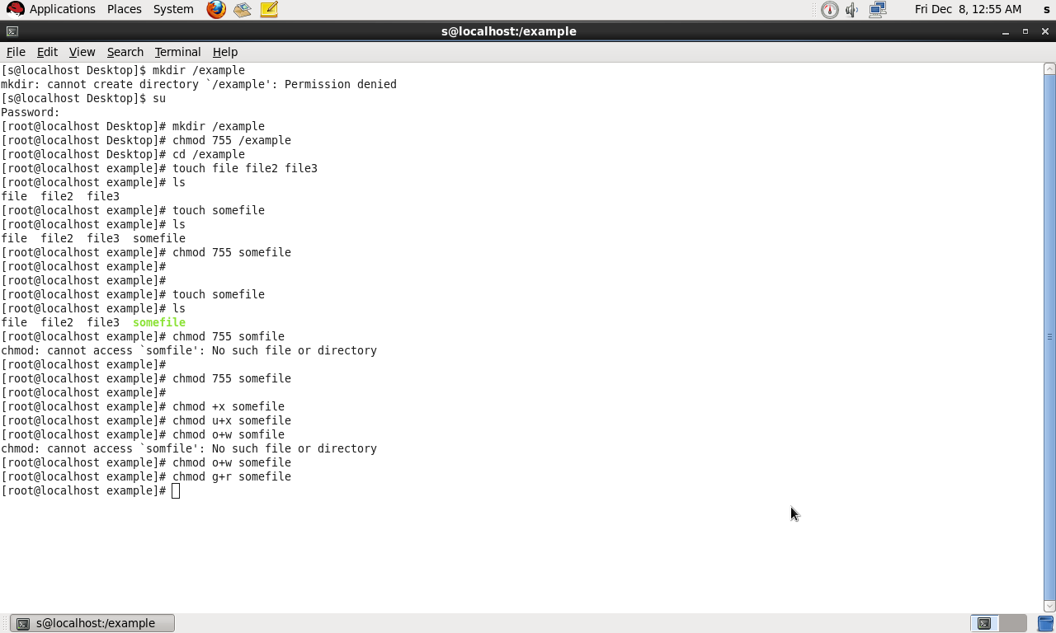

Use chmodg+s,o+t/somefile to set the set group ID bit and sticky bit on the shared group directory.

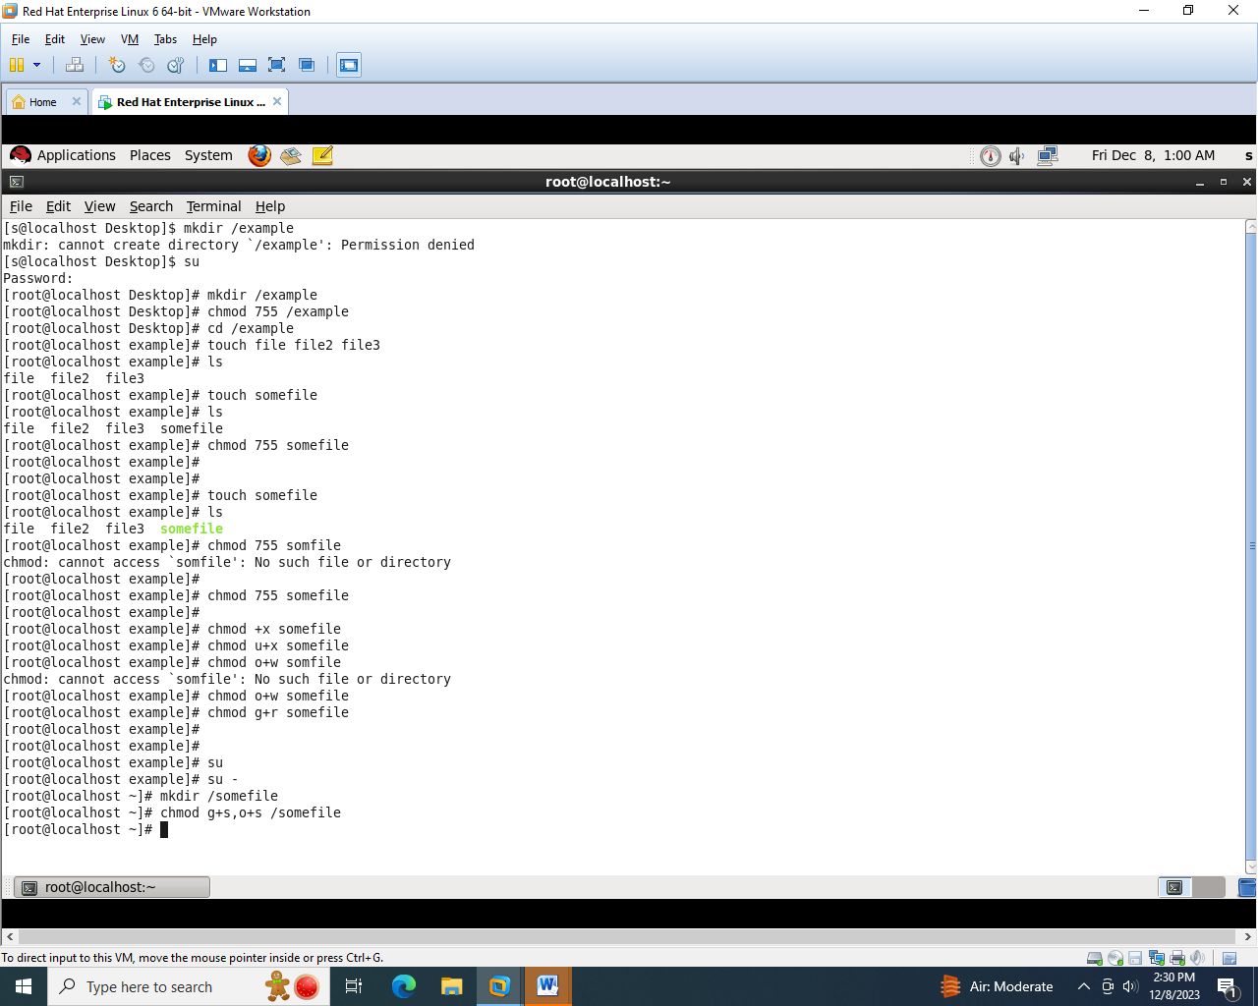

**Practical 5**

AIM : Firewall and Cryptographic services

**Setting server with iptables**

Step 1:- open terminal window and type the following command to display the current configuration

#iptables -L –v

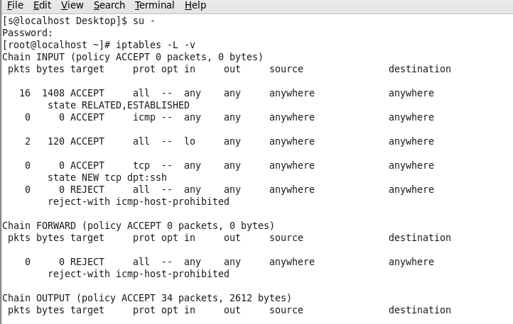

#iptables –P INPUT ACCEPT

#ipables –P OUTPUT ACCEPT

#iptables –P FORWARD ACCEPT

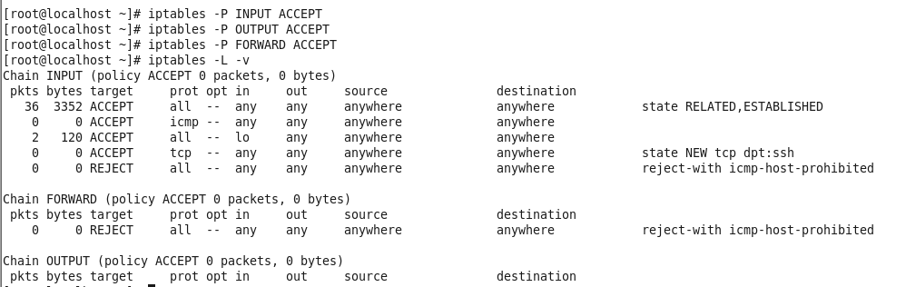

Step 2:- now flush all other rules #iptables –F



Step 3:- #iptables –L –v to verify that the policy is set to ACCEPT for all three chains in the filter tables

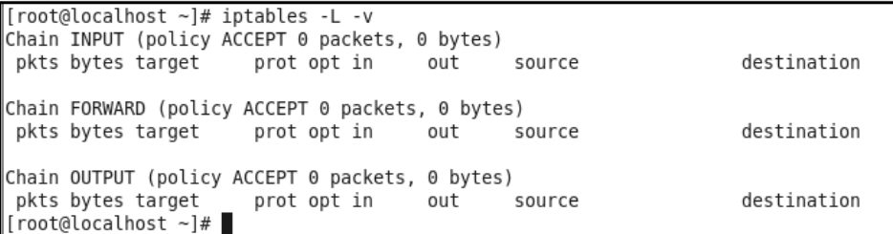

Step 4:- time to start configuring the firewall

#iptables –P INPUT DROP

#iptables –P OUTPUT DROP

#iptables –P FORWARD DROP

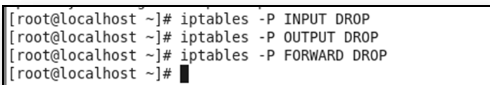

Step 5:- At the point all traffic is blocked, so its time to open your firewall and allow the traffic that you want to pemit.Open the lookback interfaces first

#iptables –A INPUT –I lo –J ACCEPT

#iptables –A OUTPUT –o lo –J ACCEPT

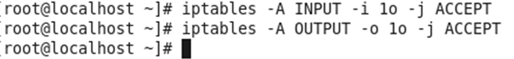

Step 6 :- Now configuring to send a reply to the originator of the SSH request. To open your vitual machine to also send a reply,use the following command

#iptables –A OUTPUT –m state – state ESTABLISHED,RELATED –j ACCEPT



Step 7:- now that SSH is open,you’ll still need to open the HTTP port. To do this use the following command:

#iptables –A INPUT –p tcp –dport 50 –j ACCEPT



Step 8:- to permit TCP traffic to get through as well,you need to allow both port 21 and port 20 though the INPUT chain.

#iptables –A INPUT –m multiport –p tcp –pot 21,20 –j ACCEPT



**Setting up cryptographic services**

STEP 1:- to check or verify the package gpg is installed or not. Type the following command: Rpm-q gpg

STEP 2:- to create a self signing certificate.type the following command: Gpg –gen –key

Follow the wizard to create a certificate-

Select the algorithm you want to generate the key pair.press 1 keys to set RSA for default

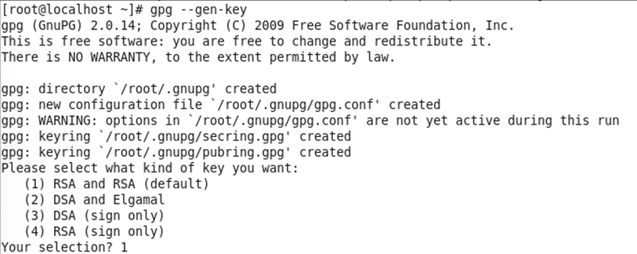

Enter the RSA key size that you want to generate key pair.-default value is 2048



Enter the validity of your key pair.0 option is used to key dose not expire and remaining option will provide limited amount of days,weeks,months and years of your key will valid.

Once entered all option.Click yes

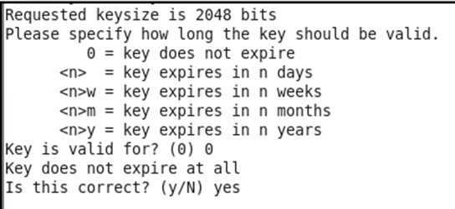

Enter your real name and email address and provide some comment for key pair generation Finally give your confirmation to gpg key generation with O(press capital O)

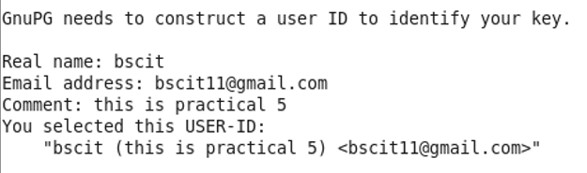



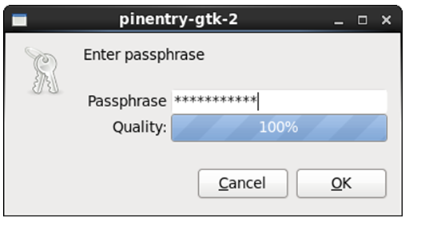 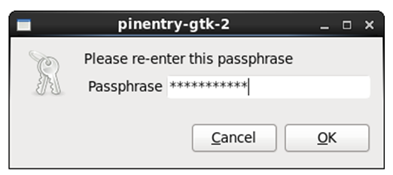

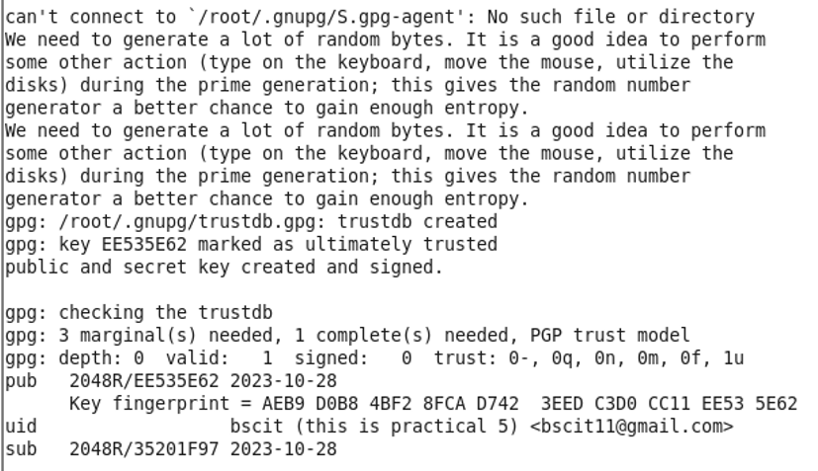

After generating your private/public key pair export this keys-



>”

After generating your private/public key pair export this keys-





Hello bscit how are you[root@localhost ~]# gpg –e secret.txt

You did not specify a user ID. (you may use “-r”)

Current recipients:

Enter the user Id. End with an empty line: bscit

Current recipients:

2048R/12701D43 2023-10-28 “bscit (this is practical 5) <bscit11@gmail.com>"

Enter the user Id. End with an empty line: bscit

gpg: skipped: public key already set

Current recipients:

2048R/12701D43 2023-10-28 “bscit (this is practical 5) <bscit11@gmail.com>"

Enter the user Id. End with an empty line:

**Practical 6**

**A] AIM : Configuring NFS Server and Client**

Step 1 : Check and verify the nfs package is installed or not

**rpm -q nfs-utlis**

Step 2 : Create a share

d directory in root (/). After creating the directory you want to share, make sure that incoming users also have permissions on that share. To do this, you'll use regular Linux permissions.

In this case, use chmod -R 777 nfsshare and put share directory in exports file.

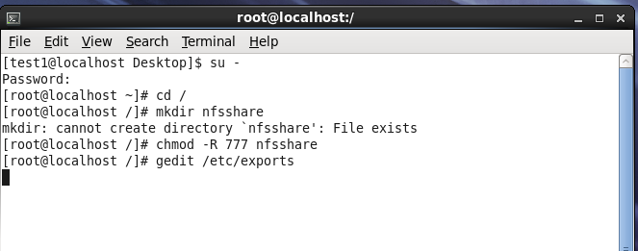

Step 3: The exports file is empty file. You add the following directory and there permissions in this file. Save and exit this file.

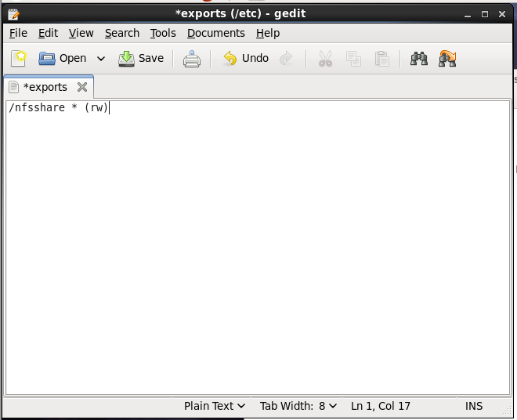

Step 4: Use **service nfs restart** to restart the NFS server and have it of fer the new share.

Step 5: Use **chkconfignfs on** to make sure that the NFS server star is at a server reboot.

Step 6: To verify that the share is available, use **showmount -e localhost**, which shows all exported shares on the local computer.

**B] AIM : Configuring Samba**

Part 1 = Connecting from windows to linux [ access windows file in linux using smbclient]

**On Window machine**

Step 1: Right click on My Computers 🡪Properties 🡪 Computer Name 🡪Change the WORKGROUP Name to WORKGROUP🡪 click on OK 🡪click on OK.

Step 2: Save the changes and restart the computer. On D drive🡪 create one folder🡪common and right click on that folder 🡪 go to properties🡪select sharing tab and share this folder to everyone 🡪 click close.

Step 3: In the shared folder create a new file named example.txt and find windows ip address. Open the cmd and type ipconfig command.

Note down the ip address of your internet connection

**In RHEL**

Step 1 : Check whether samba is installed or not by using rpm command

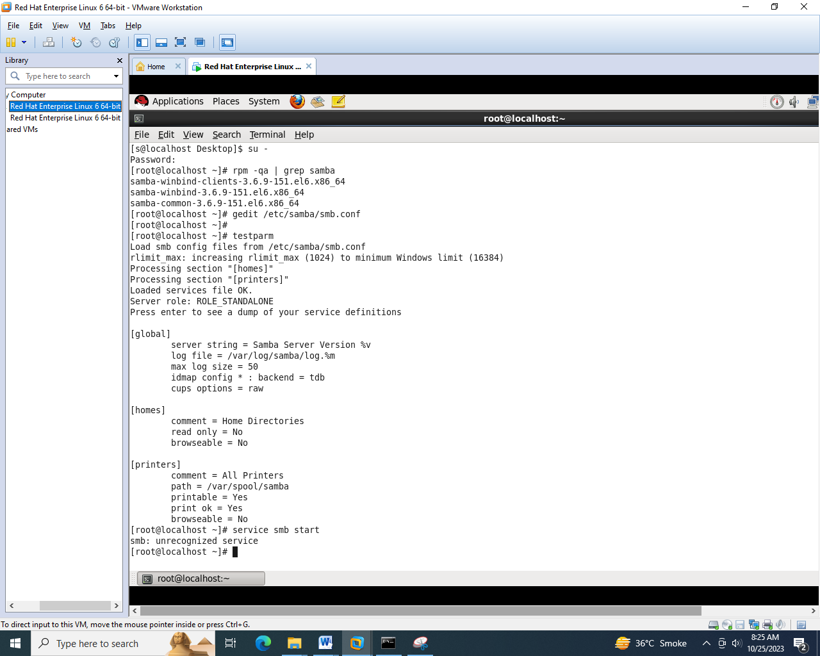

Step 2 : Open terminal window and take super user permission using su – command and open samba configuration file in **/etc/samba/smb.conf**



Step 3 : Add the window ip address and ip address and network information in configuration file. Save and exit the file

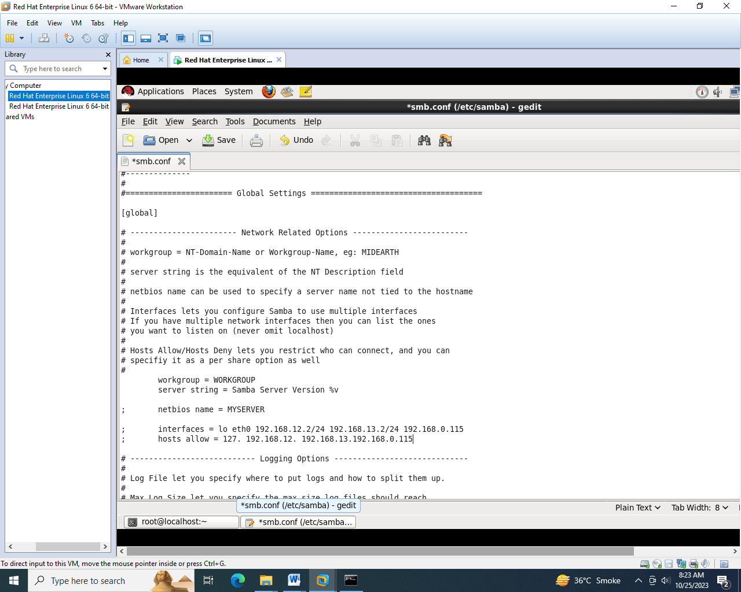

Step 4 : Now start service smb and type the following command –

Testparm 🡪 enter 🡪 enter





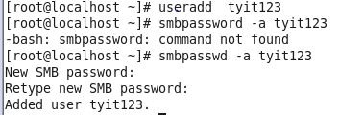

Part 2 = Connecting from linux to window

Step 1 : Create a shared directory, Itshare in /home directory

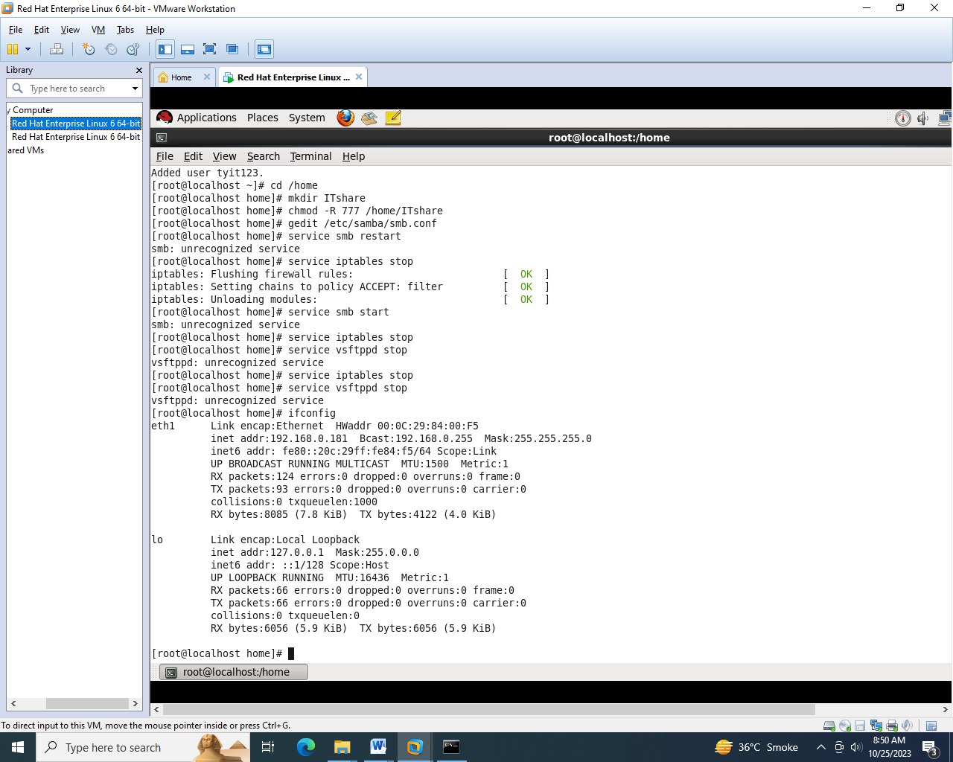

Step 2 : add share directory information in the smb.conf file at the buttom

(public)

comment = public stuff

path = /home/ITshare

public = yes

writable = yes

pritable = no

write list = +stall

Step 3 : restart smb service

Servicesmb restart

Step 4 : Stop ftp firewall

Serviceiptables stop

Step 5 : stop ftp service

Servicesftpd stop





**Practical 7**

**AIM :** DNS, DHCP and Mail Server

**Configure DNS**

Step 1: Check ip address

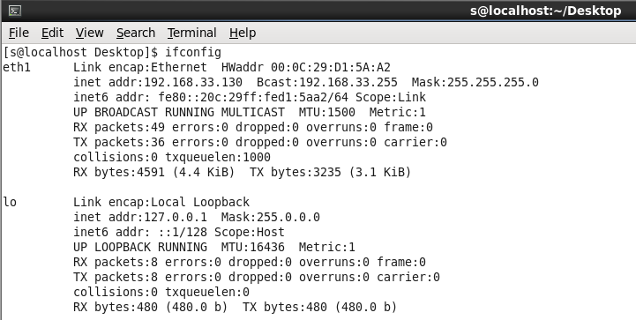

Step 2: Check hostname

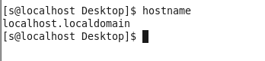

Step 3: Open /etc/hosts file and add hostname and ip address in that file. Save and exit.

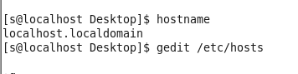

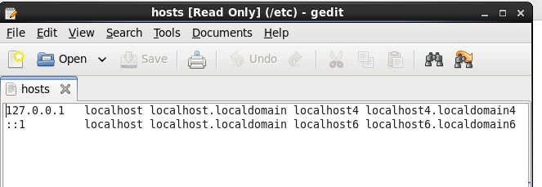

Step 4: Open /etc/sysconfig/network file and set hostname in/etc/sysconfig/network file.

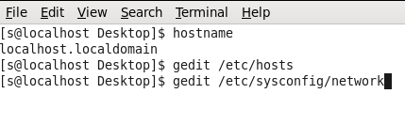

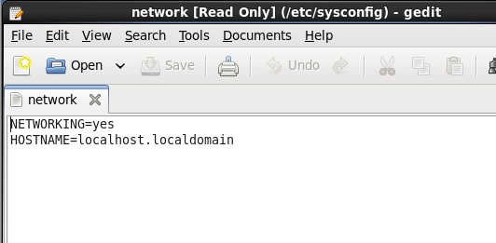

Step 5: Open resolv.conf file and set name server with your ip address.

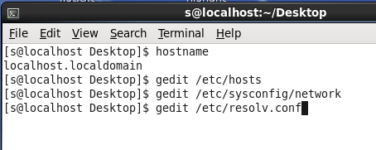

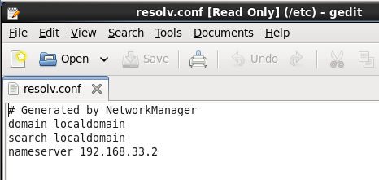

Step 6: Install bind package. And make changes in /etc/named.conf file.

**Configuring DHCP**

Step 1:Assign a static IP address to linux server machine.

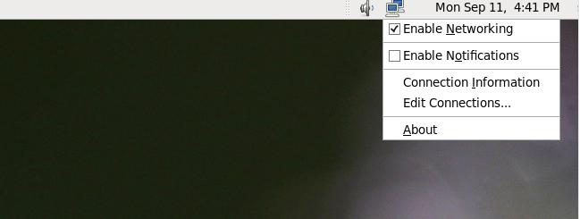

Step 2 : The network connection wizard will open. Select your Ethernet card name and click on edit button.

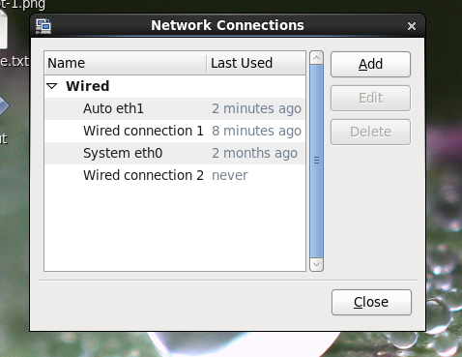

Step 3: Editing system eth0 window will open. Add manual ip address in this window . Click on apply button.

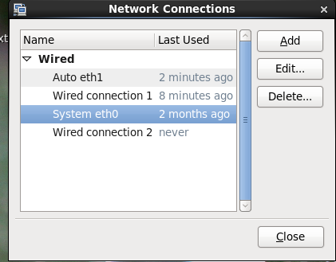

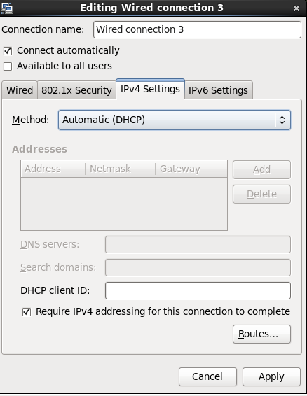 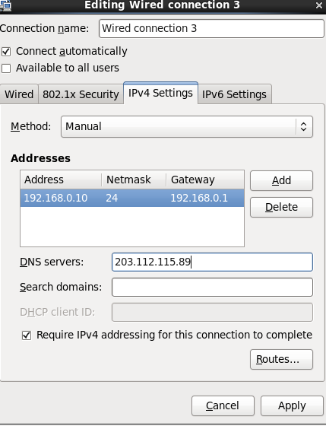

**Practical 8**

**AIM :** Configuring Web Server

**Configuring Apache on Red Hat Enterprise Linux**

Step 1: Install Apache Web Server(httpd) and check it installed or not –

Step 2:Enable the httpd service using service command and start all the runlevels of httpd service using chkconfig command.

servicehttpd restart

chkconfighttpd on

chkconfighttpd—list

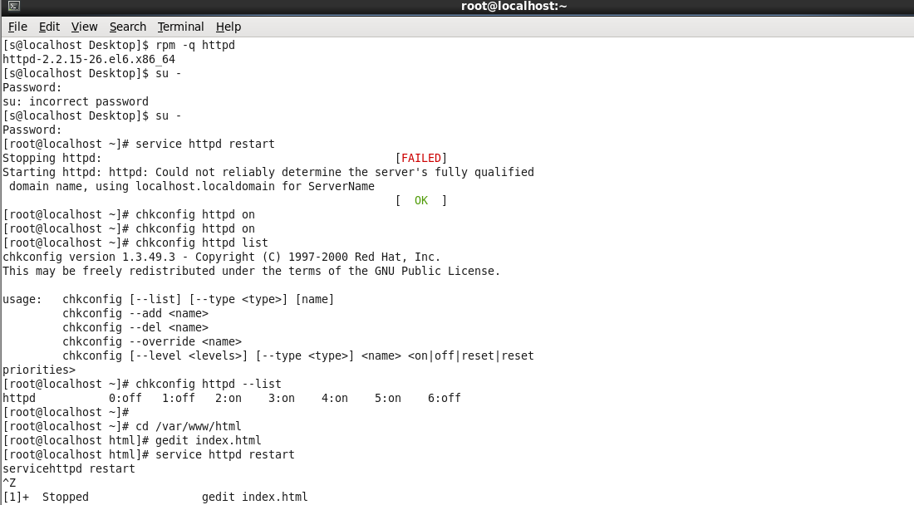

Step 3: Create an index.html file and add some html code and save in /var/www/html directory.

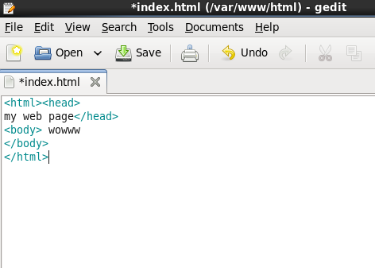

Step 4: restart the httpd service.

servicehttpd restart.

Step 5: open web browser and type <http://localhost/to> open the file.

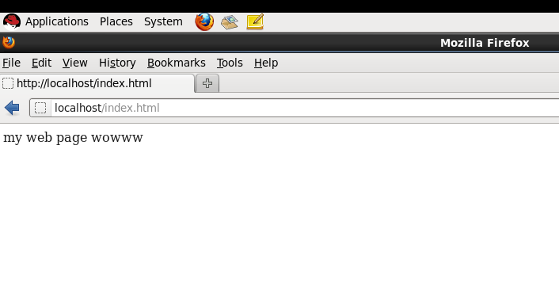

* **write a script to monitor activity on the Apache web server**

step 1: create a shell script using gedit and type the following code –

gedit test.sh

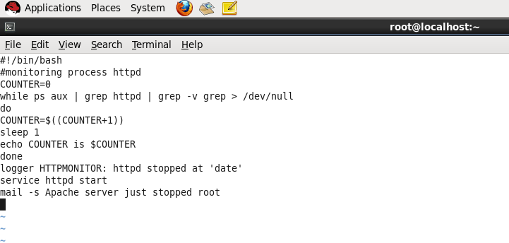

step 2: save the file and assign execute permission - chmod -R 777 test.sh

step 3:execute the script –

sh test.sh

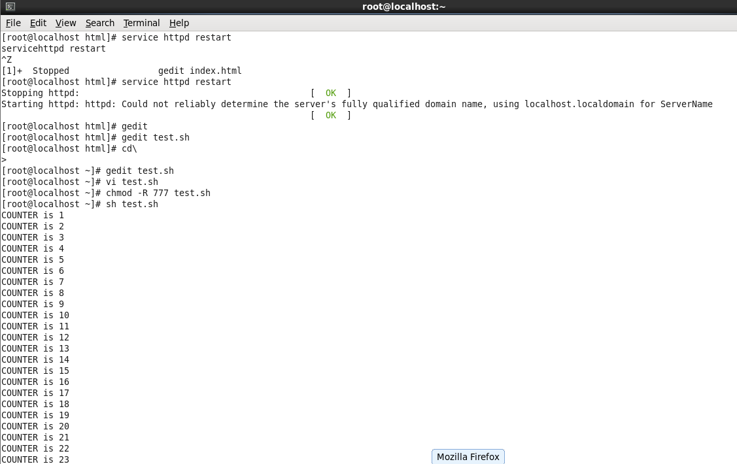

* **Using the select Command-**
* Write a shell script that asks the user to enter the name of an RPM or file that the user wants to query.
* Write a shell script to present a menu that provides different options that allow the user to do queries on the RPM database. The script should offer some options, and it should run the task -

The following options must be presented -

a.Find the rpm from which this file originates.

b. Check that the rpm where the user has provided the name is installed.

c. Install the rpm

d. Remove the package.

echo Enter the name of an RPM or File

read RPM

echo ‘select TASK in check from the menu’

select TASK in 'check from which rpm file comes’ ‘check if this rpm is installed' ‘install this rpm' 'remove the rpm’

do

case $REPLY in

1) rpm -qf $RPM*;;

2) prm-qa | grep $RPM*;;

3) rpm-ivh $RPM*;;

4) гpm-e $RPM*;;

*) echo error && exit 1;;eEsac

echo you have selected TASK STASK

if [ -n "TASK"]

then

echo you have selected TASK $TASK

break

else

echo invalid choice

fi

done

**Practical 9**

**AIM :** Writing Shell Scripts.

Example 1 =

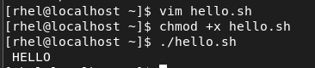

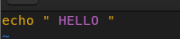



Example 2 =

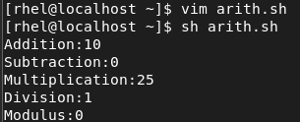

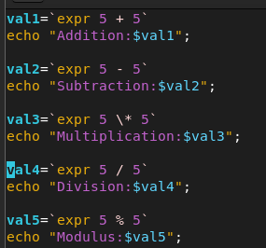



Example 3 =

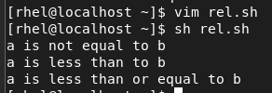

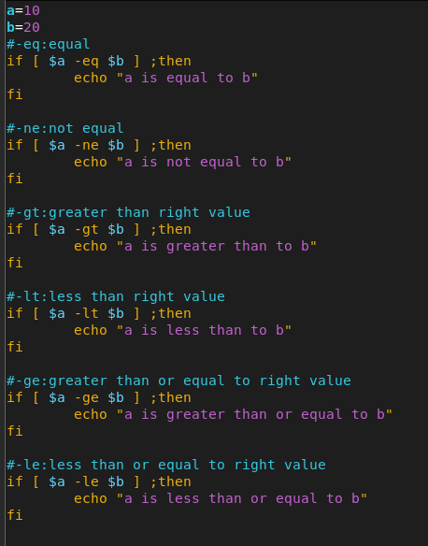

**Practical 10**

**A] AIM :** Configuring network server as an installation server

**B] AIM :** Setting up an TFTP AND DHCP Server for PXE boot

**Setting up a TFTP and DHCP server for PXE boot**

The following steps most be performed to prepare for a network installation

🡪 Configure the network (NFS, FTP, HTTP, HTTPS) server to export the installation tree

🡪 Configure the files on the the server necessary for network booting.

🡪Configure which hosts are allowed to boot from the network configuration.

🡪Start the tftp service.

🡪Configure DHCP.

🡪Boot the client, and start the installation

**What is Clustering ?**

Clustering is establishing connectivity among two or more servers in order to make it work like one. Clustering is a popular technic among Sys-Engineers that they can cluster servers as a failover system, a load balance system or a parallel processing unit.

By this series of guide, I hope to guide you to create a Linux cluster with two nodes on Redilau/CentOS for a failover scenario.

Since now you have a basic idea of what clustering is, let's find out what it means when it comes to failover clustering. A failover cluster is a set of servers that works together to maintain the high availability of applications and services.

**Step 1: Installing Clustering in Linux**

🡪So let's start installing these packages in all three servers. You can easily install all these packages using yumpackage manager.

🡪I will start by installing "ricci" package on all these three servers.

# yum install "ricci

# yum install “luci"

# yum install "ces"

# yum install "cman"

# rpm -qa I egrep "riccillucilmodciclusterloesleman"

#servicericci start OR

# /etc/init.d/ricci start

Start Ricci Service on Cluster Server

Start Ricci On. Node 01

Start Hicci On Node 02

#cd/etc/cluster

#pwd

-Enter passwords for ricci user.

#passwdricci

#ces-h 192.168.10.230-createclustertecmint_cluster

You can see after entering above command, cluster.conf file is created in /etc/cluster directory.

#os-h 192.168.10.230-addnode192.168.10.210

#cos-h 192.168.10.230--addnode192.168.10.211

#ces-h 192.168.10.230-lsnodes

**What Is Fencing?**

🡪If we think of a setup with more than one nodes, it is possible that one or more nodes can be failed at some point of time.

🡪So in this case fencing is isolating the malfunctioning server from the cluster in order to protect and secure the synced resources.

🡪Therefore we can add a fence to protect the resources shared within the cluster.

**What is Fall over?**

🡪Imagine a scenario, where a server has important data for an organization which the stakeholders need the organization to keep the server up and running without any downtime experienced. In this case we can duplicate the data to another server (now there are two servers with identical data and specs) which we can use as the fail-over.

🡪By any chance, one of the servers goes down, the other server which we have configured as the fail-over will take over the load and provides the services which were gien by the first server. In this method, users will not be experienced the down time period which was caused to the primary server.

🡪 The first server act as a Cluster server and other two as nodes.

Cluster Server: 192.168.10.230

Hostname: clserver.test.net node01: 192.168.10.210 Hostname, ndol server,test.net

node02: 192.168.10.211

Hostname: nd02server.test.net

Step 1: How to Add Fencing to Cluster Server

1.First we have to enable fencing on the cluster server, for this I will use below two commands.

# ch 192.168.10.230-fencedaempest_fail_delay()

#cosh 192.168.10.230-fencedapost join_delay10 Enable Fencing on Cluster

-h: Chaiter host IP address

setfencedaemon: Applies the changes to the fencing daemon

post_fail_delay: Time in seconds which the daemon waits before fencing a victim server when a node has been failed.

postjoin_delay: Tine in seconds which the daemon wait befire fencing victim server when a node has joined the cluster.

# ces- 192.168.10.230--iencedevtecmintfence agent=fence_virt

#ces-h192.168.10.230--Isfenceopts

Step 2: Add Two Nodes to Fence Device

# ccs -h 192.168.10.230—addmethod Method01 192.168.10.211

# ccs -h 192.168.10.230—addfenceinstteemintfence192.168.10.210 Method01

# ccs -h 192.168.10.230—addfenceinstteemintfence192.168.10.211 Method01

Step 3: Add Failover to Cluster server.